Lydia Cancer Association’s Breast Cancer
Love, Cure, Awareness
2023 Ride
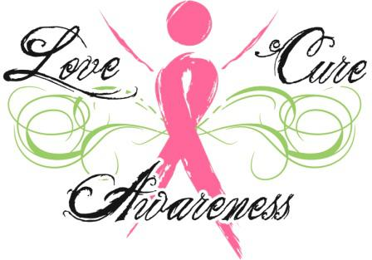
Saturday, October 28, 2023
Lydia Cancer Association Building in Lydia
7205 Weeks Island Road, New Iberia, LA
Registration @ 8:00 AM, Opening ceremony @ 9:00 AM, Depart @ 9:30 AM
Register Day-of or Pre-Register Acceptable
All street legal vehicles are welcomed
We would like to extend an invitation to you to support our 1st Breast Cancer “LOVE, CURE, AWARENESS” RIDE. All donations are tax-deductible. TAX ID #81-0612072.
Lydia Cancer Association provides limited financial assistance to clients in Iberia, St. Martin, St. Mary, and Vermilion Parishes.
Join us in a ride to 3 nursing homes
Iberia Manor South, Consolata Home, Maison Teche
Please decorate your vehicle & yourself in PINK.
Since same time as Halloween, we can treat the residents with Pre-Packaged
soft candy, cakes or small drinks like hugs or capri sun. (This is Optional)
Current Covid guidelines will apply

Please consider one of the following:
____Platinum Sponsor - $800.00 will get your name on t-shirts & a team of 5 with 5 shirts & 1 vehicle ____Diamond Sponsor - $600.00 will get your name on t-shirts & a team of 4 with 4 shirts & 1 vehicle
____Gold Sponsor - $300.00 will get your name on t-shirts & a team of 3 with 3 shirts & 1 vehicle
____Silver Sponsor - $200.00 will get your name on t-shirts & a team of 2 with 2 shirts & 1 vehicle
____Bronze Sponsor - $100.00 will get your name on t-shirts

We want to thank you for participating in our event. Without your help, we would not be able to offer this kind of assistance. Attached is a registration form for your company's participants. Please feel free to make copies.
If you have any questions, please call Lydia Cancer Association at 337-367-1192.
2023 Love, Cure, Awareness Ride Sponsorship
Saturday, October 28, 2023
Lydia Cancer Association Building in Lydia
7205 Weeks Island Road, New Iberia, LA
Registration @ 8:00 AM, Opening ceremony @ 9:00 AM, Depart @ 9:30 AM

Business Name __________________________ Contact _________________________
Email address: ___________________________ Phone # _________________________
Mailing Address ______________________________
City _________________________, State ______________ Zip code ___________

Sponsorship Type _______________________ Sponsorship Amount $_____________

2023 T-Shirt sizes (S – 4X) Deadline October 10, 2023 to ensure your name will be on T-Shirt (Enter t-shirt size on blank)
T-Shirt Size ___ T-Shirt Size ___ T-Shirt Size ___ T-Shirt Size ___T-Shirt Size ___
Breast Cancer Survivors (circle 1) Yes No
Online Sponsorship is available through our website: https://www.lydiacancerassociation.org or mail this form to: Lydia Cancer Association - P.O. Box 731 - Lydia, LA 70569
If you have any questions, please call Lydia Cancer Association at 337-367-1192.

